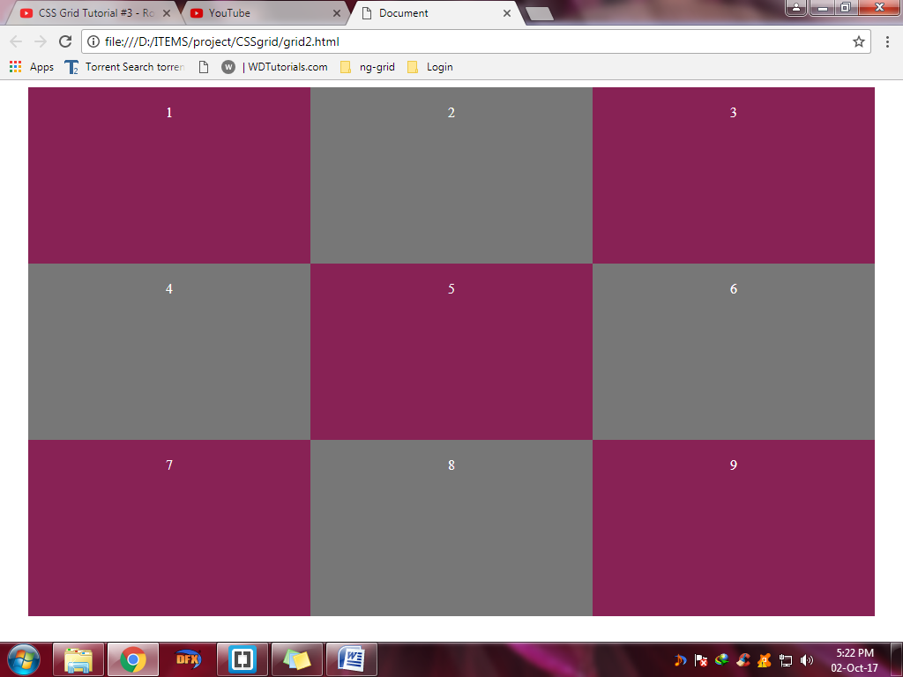We are using grid2.html for this design

1)Grid rows: We can define automatic height for each of the divs.Our design is 3 columns width now.So for this we add a property

**grid-auto-rows:200px**.

So now all the divs will have height of 200px.

#main

{

text-align: center;

color: white;

max-width: 960px;

margin: 0 auto;

display:grid;

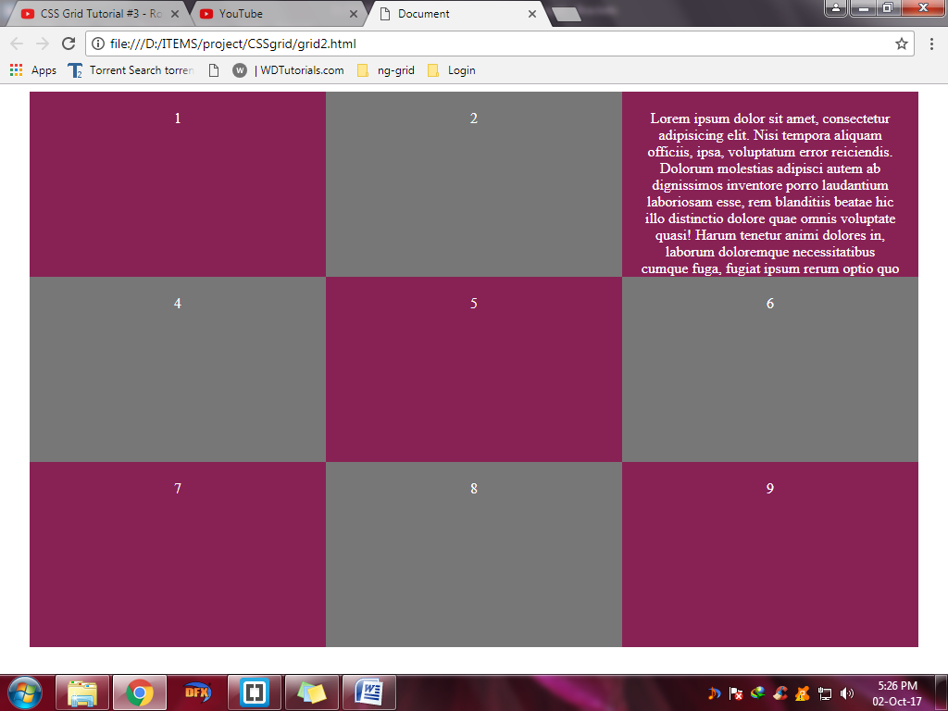 grid-template-columns:repeat(3,1fr);

grid-auto-rows: 200px;

}

2)Lets add some text in the 3rd div.Now the div looks like this.But the text doesn’t fit in.

We need to define minmax()

grid-auto-rows: minmax(200px,auto);

This means minimum width is 200px max width is auto(based on the content of the text).

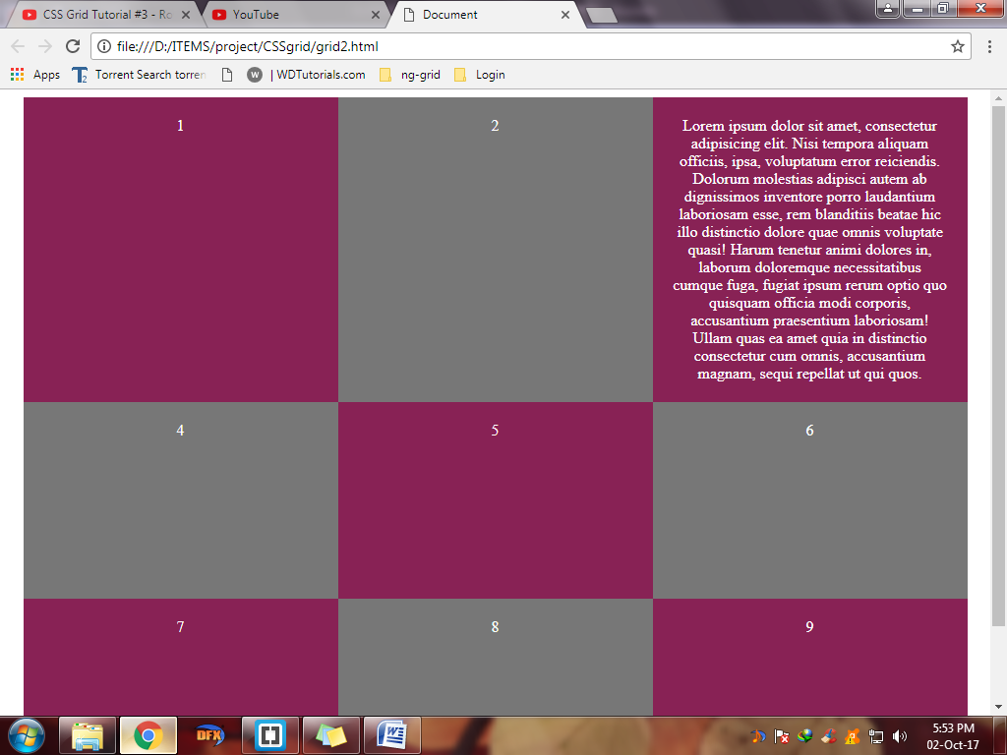

Now the text fits in

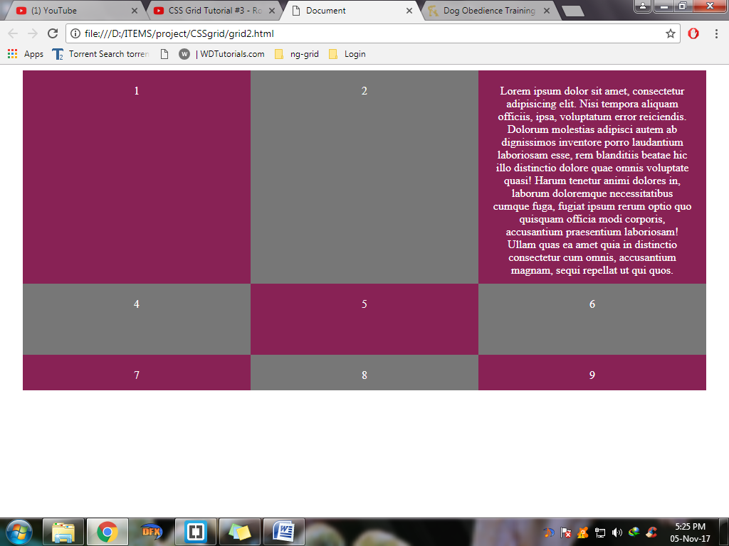3)Now like columns, we can set height for each rows. By using the property grid-template-rows.Lets do this

Grid-template-rows:300px 400px 500px 200px .So we turn off the feature minmax. So our first row is 300px next 400 next 500 and last one is empty as you see since we have 9 divs

#main

{

text-align: center;

color: white;

max-width: 960px;

margin: 0 auto;

display:grid;

grid-template-columns:repeat(3,1fr);

/*grid-auto-rows: 200px;*/

/*grid-auto-rows: minmax(200px,auto);*/

grid-template-rows: 300px 100px 50px 100px;

}

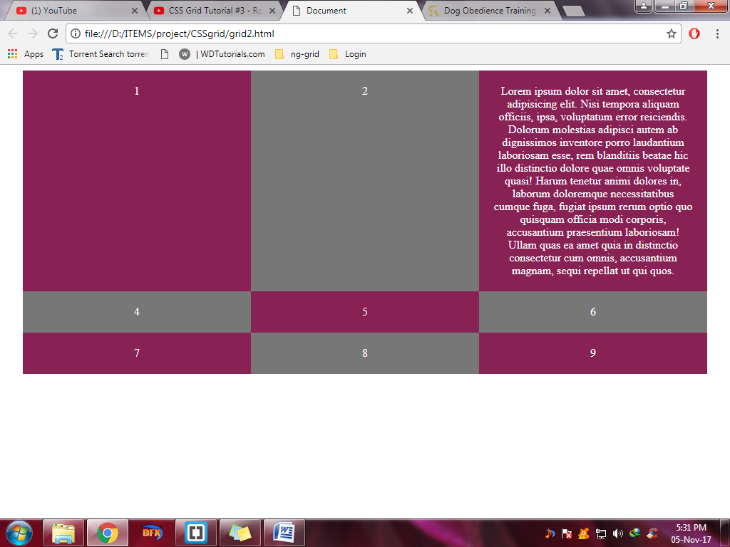

4) We may also want that our rows to have 200px min and auto max. We can set that accordingly by

Grid-template-rows:repeat(3,minmax(200,auto))

#main

{

text-align: center;

color: white;

max-width: 960px;

margin: 0 auto;

display:grid;

grid-template-columns:repeat(3,1fr);

/*grid-auto-rows: 200px;*/

/*grid-auto-rows: minmax(200px,auto);*/

/*grid-template-rows: 300px 100px 50px 100px;*/

grid-template-rows:repeat(3,minmax(200,auto))

}

So each row min=220px and max=auto 3 times

4)Grid gap :We can set gap between rows and columns using grid gap.For rows we use grid-row-gap and columns grid-column-gap.Together it combines as grid-gap

#main

{

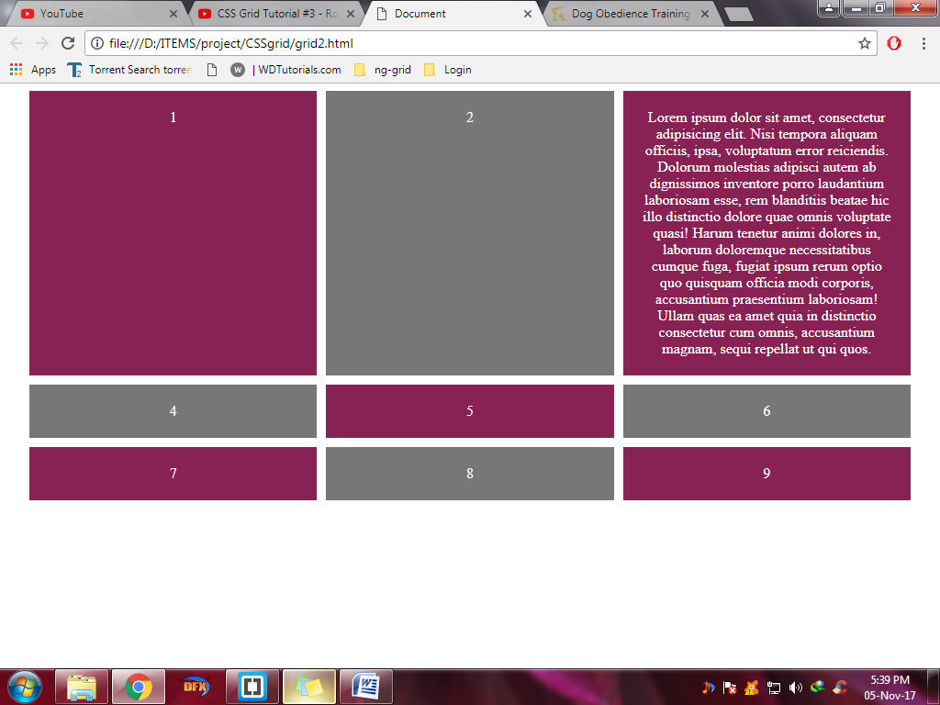 text-align: center;

color: white;

max-width: 960px;

margin: 0 auto;

display:grid;

grid-template-columns:repeat(3,1fr);

/*grid-auto-rows: 200px;*/

/*grid-auto-rows: minmax(200px,auto);*/

/*grid-template-rows: 300px 100px 50px 100px;*/

grid-template-rows:repeat(3,minmax(200,auto));

grid-gap:10px;

}